AI Assisted Coding
Lab Assignment 1.5
Erukala Keerthana
2403A51L06
B:51

Task 1: AI-Generated Logic Without Modularization (Palindrome without Functions)
Prompt Used:” write a python program to generate palindrome number without using functions with comments”
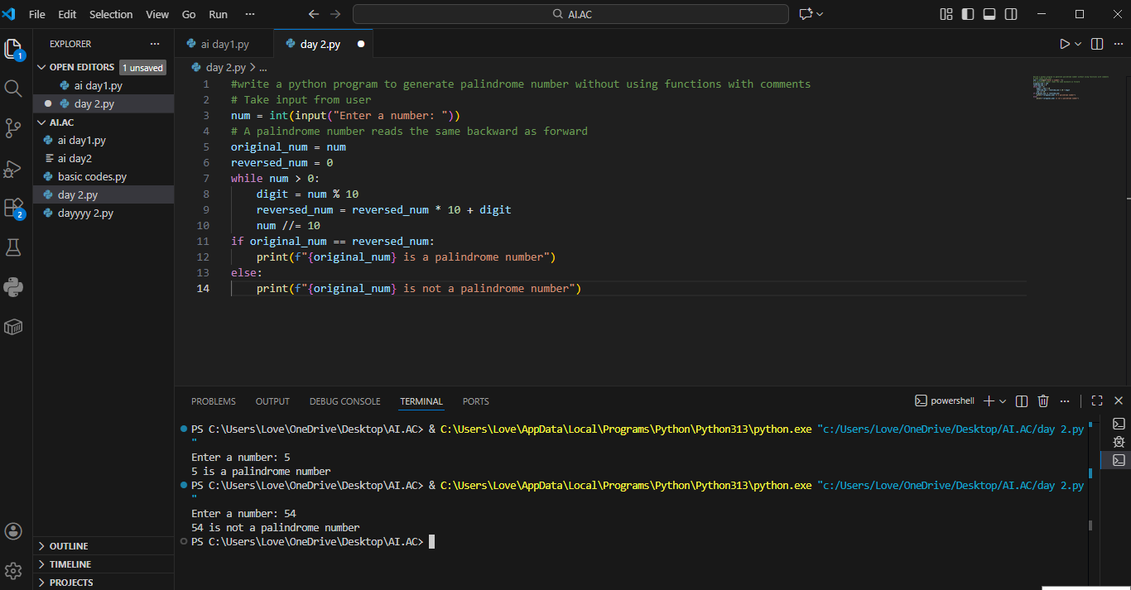

- Keeps the program simple
- Suitable for small scripts
- Easy for basic understanding
- No function call overhead

Task 2: AI Code Optimization & Cleanup Original Code:
Prompt Used: write a python program to optimize the code with comments

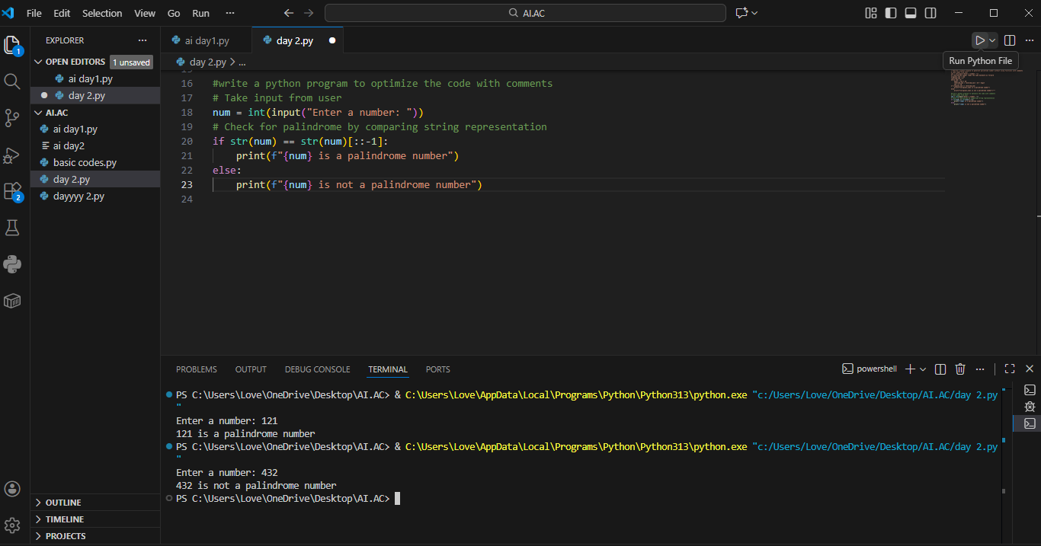

Code is cleaner and easier to maintain
The optimized version improves clarity, maintainability, and readability without affecting performance

Task 3: Modular Design Using AI Assistance (Palindrome with Functions)
Prompt Used: “ write a python program to generate palindrome number with using functions with comments”
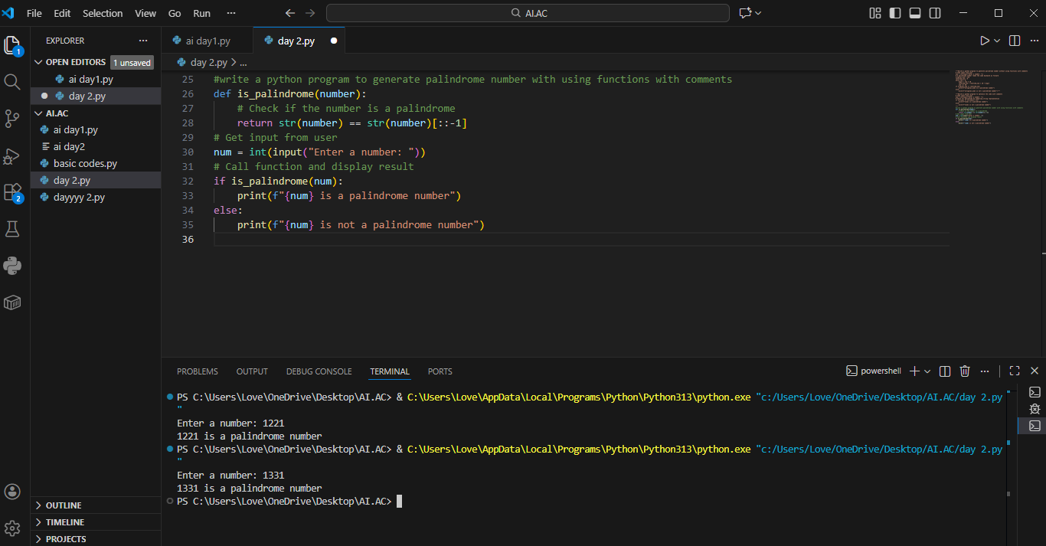

Using functions improves reusability because the same logic can be called multiple times.
It also improves readability and debugging.
Modular code is easier to maintain in large projects.

Task 4: With & Without using functions
Prompt Used:” write a python program to generate palindrome number with & without using functions with comments

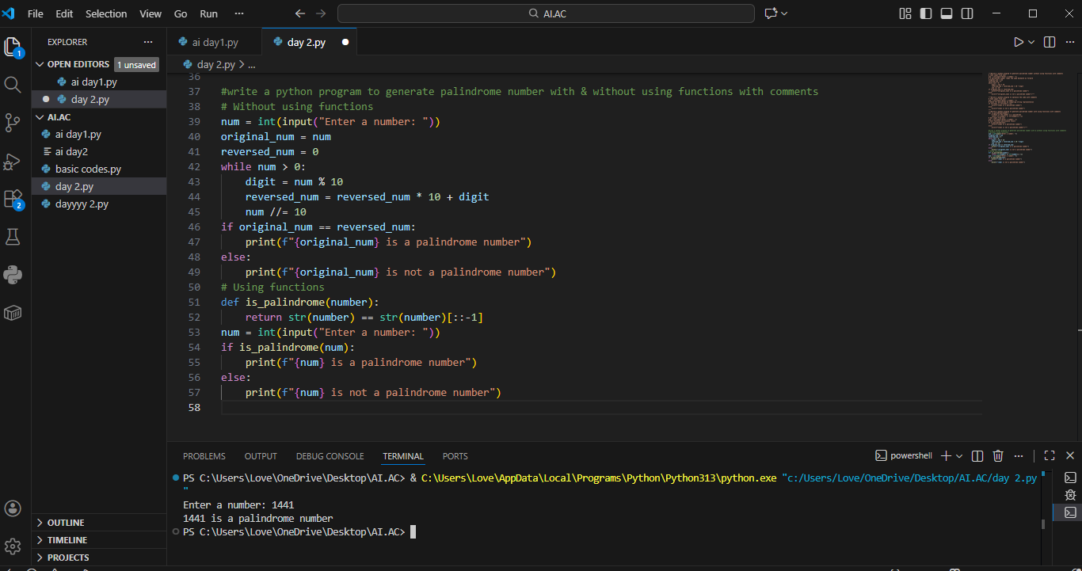

Aspect | Without Function | With Function
Programming Style | Procedural | Modular
Code Reusability | No | Yes
Readability | Moderate | High
Debugging | Difficult | Easy
Suitable for Large Programs | No | Yes
Best Use Case | Small scripts | Real-world applications

Task 5: Using Recursion
Prompt Used: “write a python program to generate palindrome number using recursion with comments”

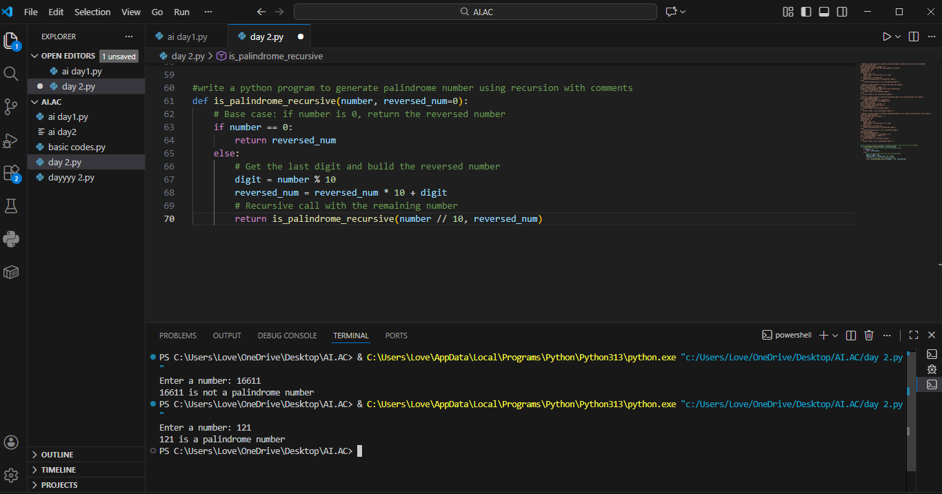

Execution Flow Explanation:
- Recursive version uses function calls and stack memory.
- Clean mathematical representation
- Useful for learning recursion concept

